UX Report

Knockout Ticket

Valentin-Gabriel Morisca

**06/06/2024**

Update - 15/06/2024

UPDATED ONCE AGAIN – 19/06/2024

For this report, I have asked two friends to go through the website and give feedback through a questionnaire written by me.

The completed questionnaires, this report, and other documentation will be present in the git repository: <https://git.fhict.nl/I516431/knockout-ticket>

Overall, inconsistency of colors between the pages, uneven spacing, no validation, no error and notifications were present in the feedback from the two users, and from other observations I had.

**AS OF 15/06/2024 – newer screenshots have been added, some pages were not added as the only change was the background image (which is seen in the other photos)**

**AS OF 19/06/2024 – newer screenshots have been added to reflect new pages and new UI elements.**

Login Page and Signup Page were not subject to changes.

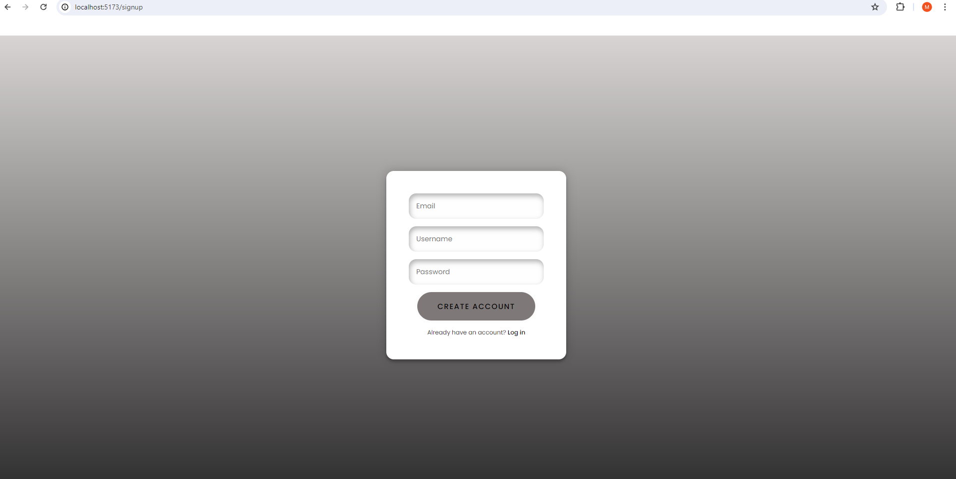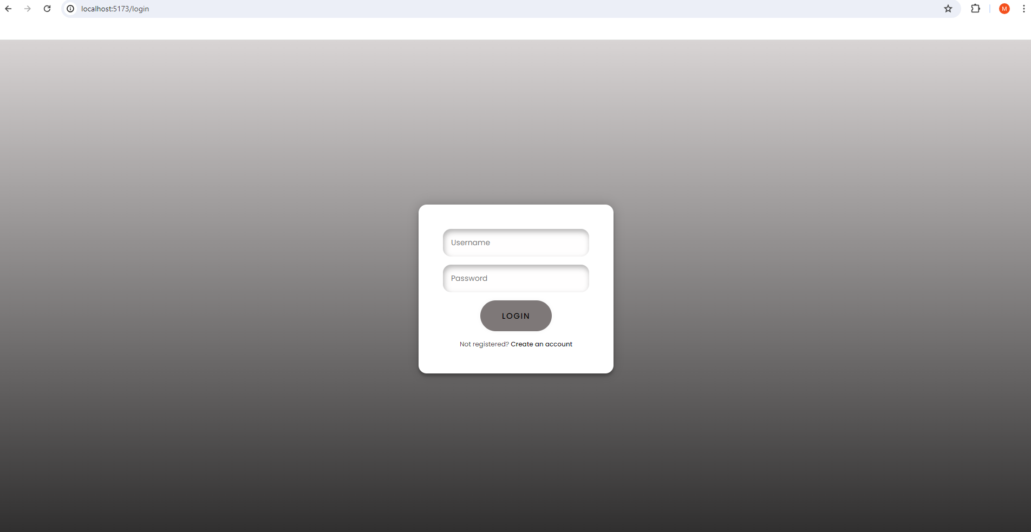

Next, the Home Page had a change, the color of the button has been changed to purple.

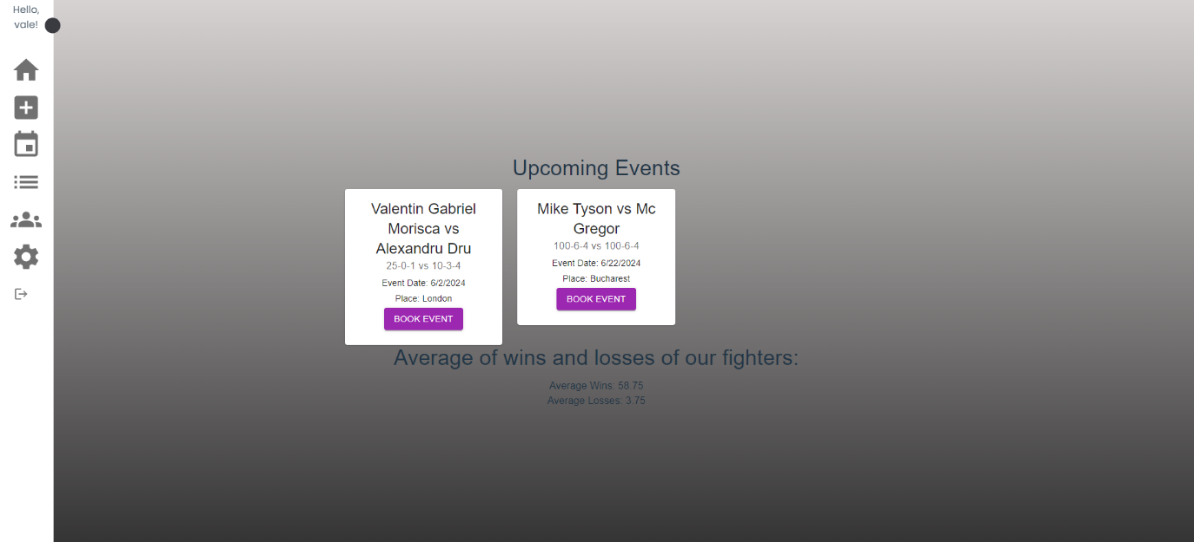 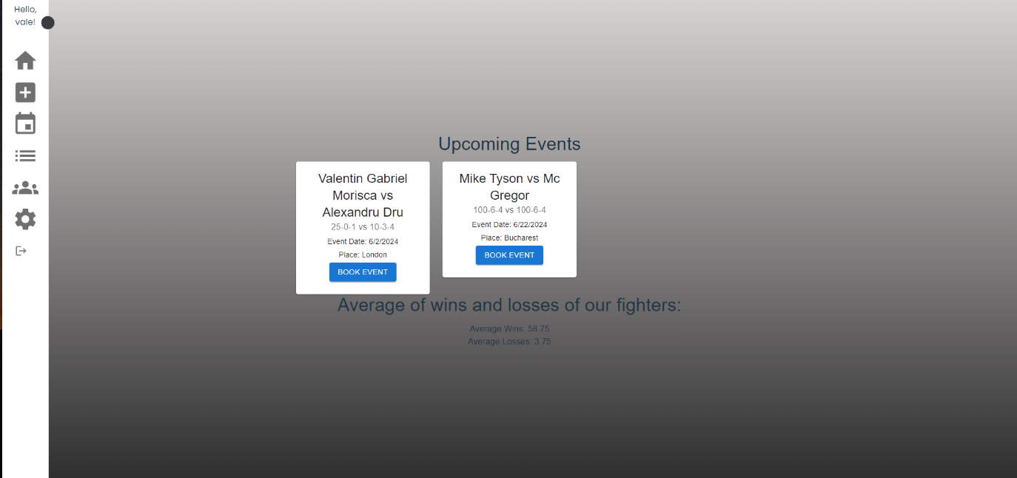

The book page had also been changed in the same manner.

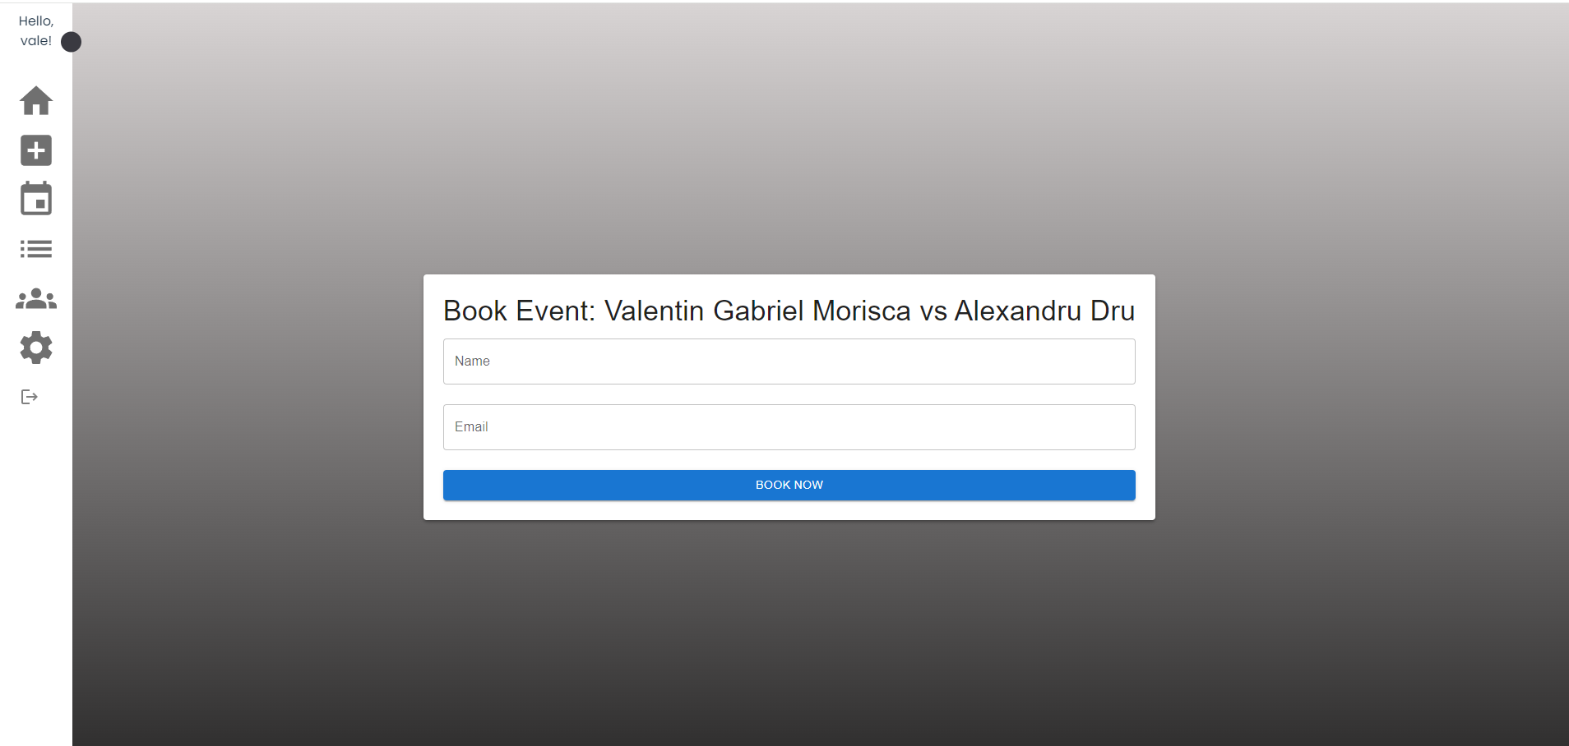

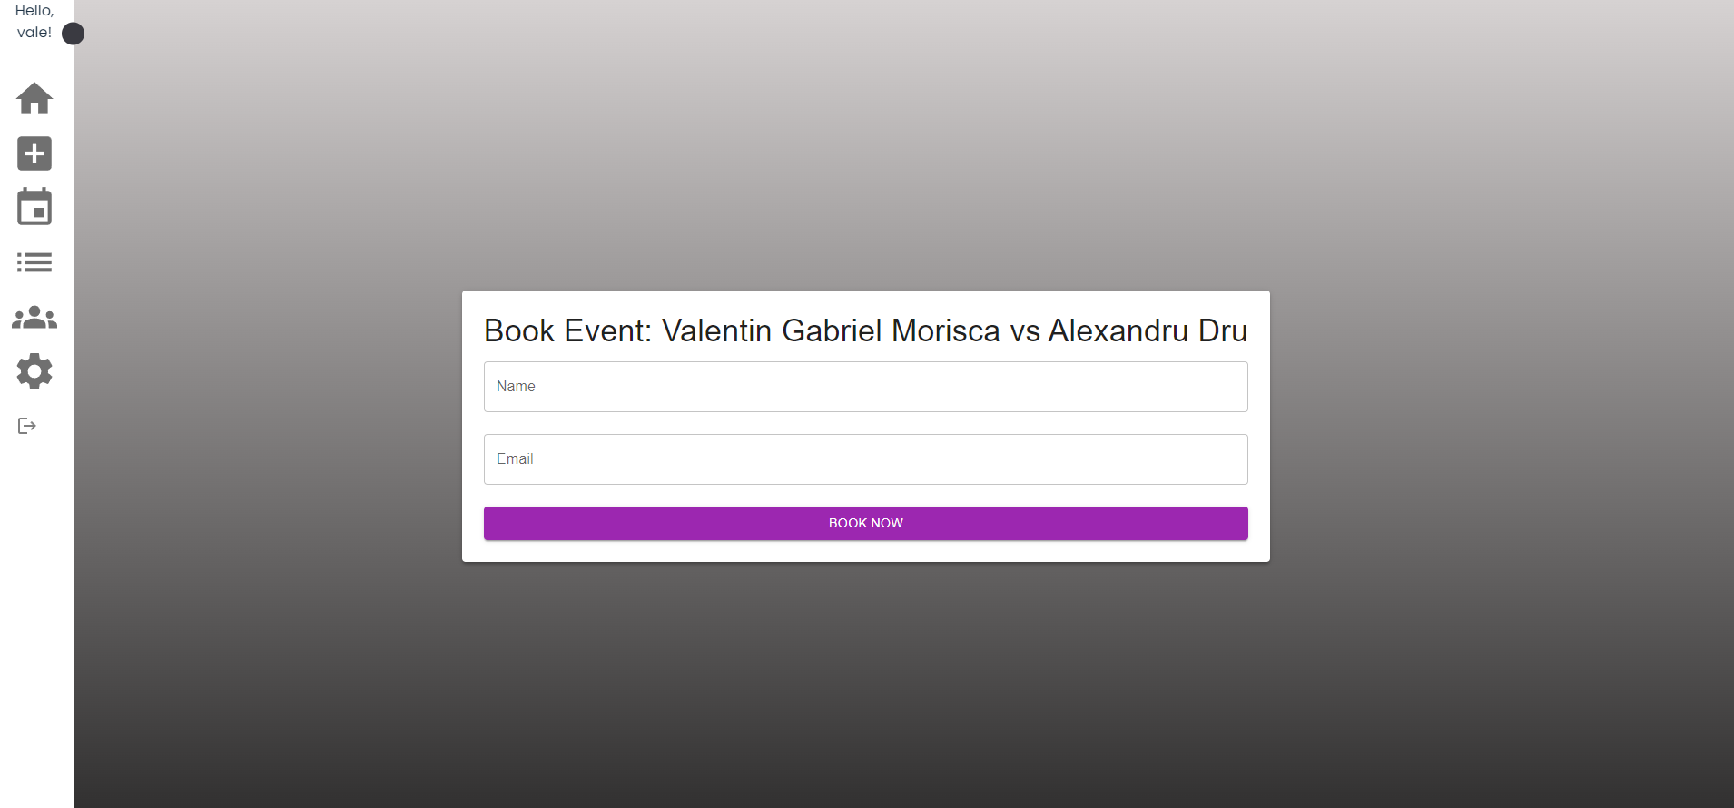

Also for the List of Boxers.

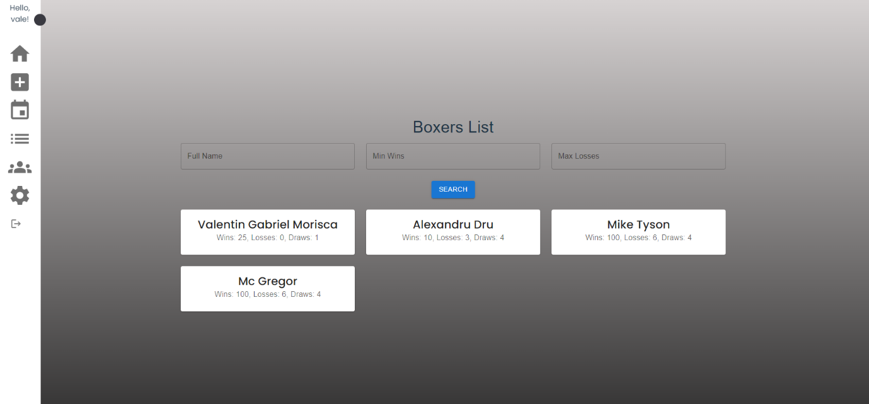

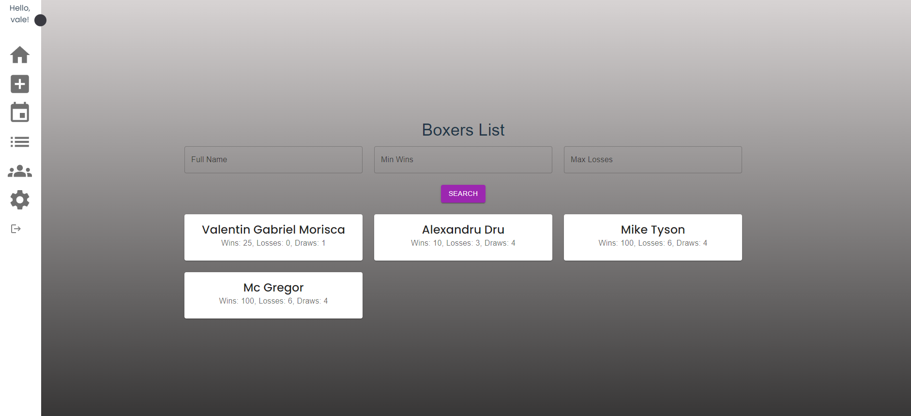

Next, the Create Boxer Page has not been affected.

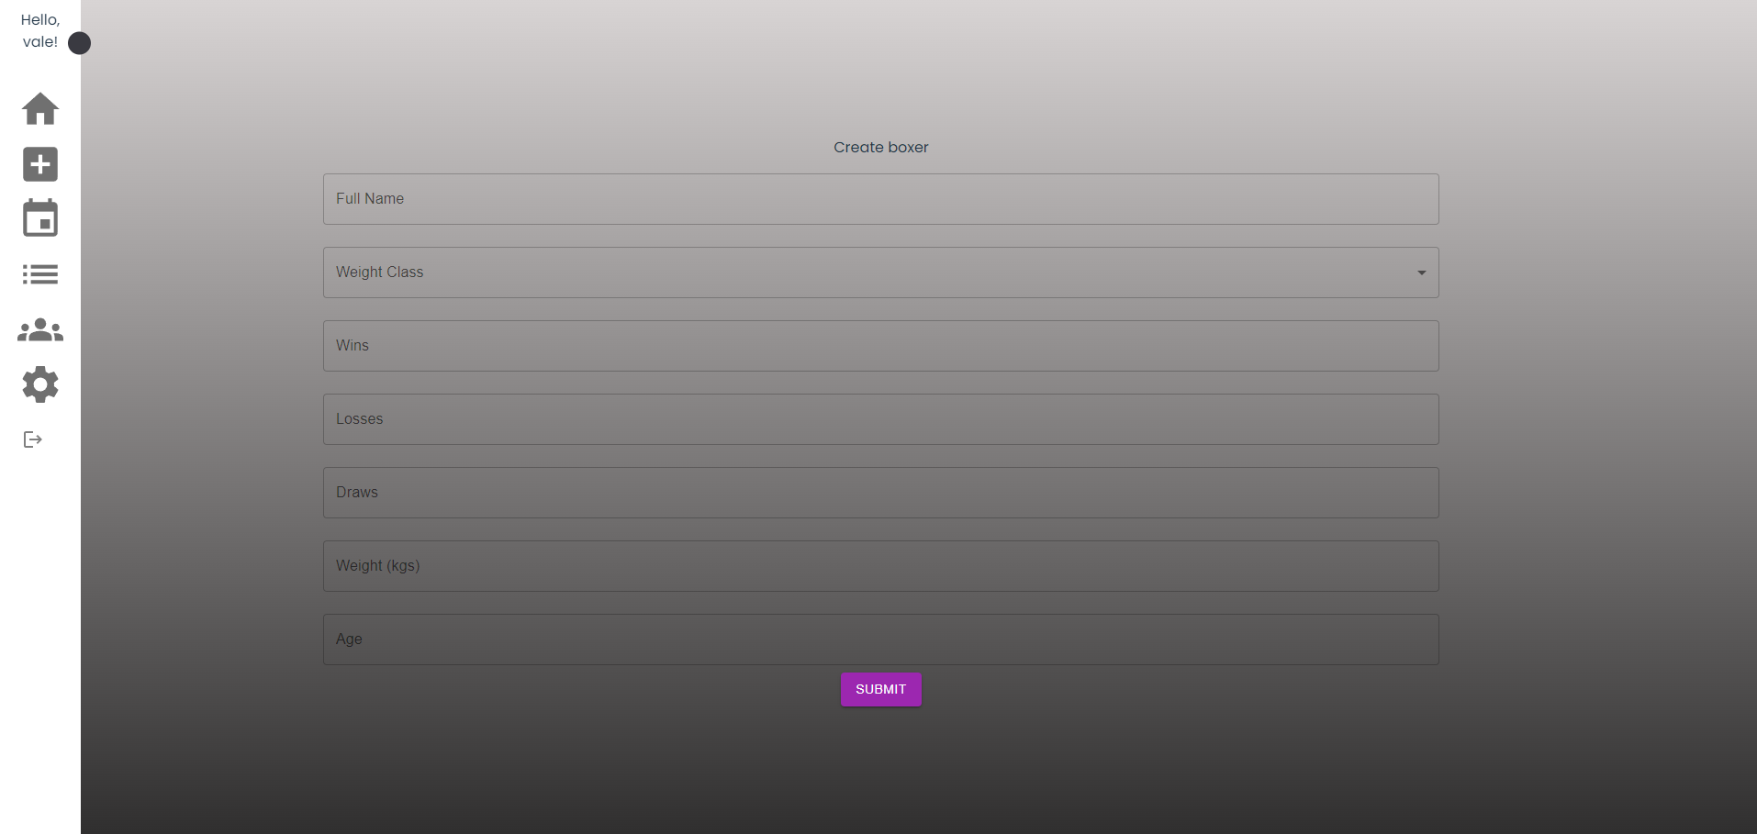

The page for Modifying a boxer has not been affected.

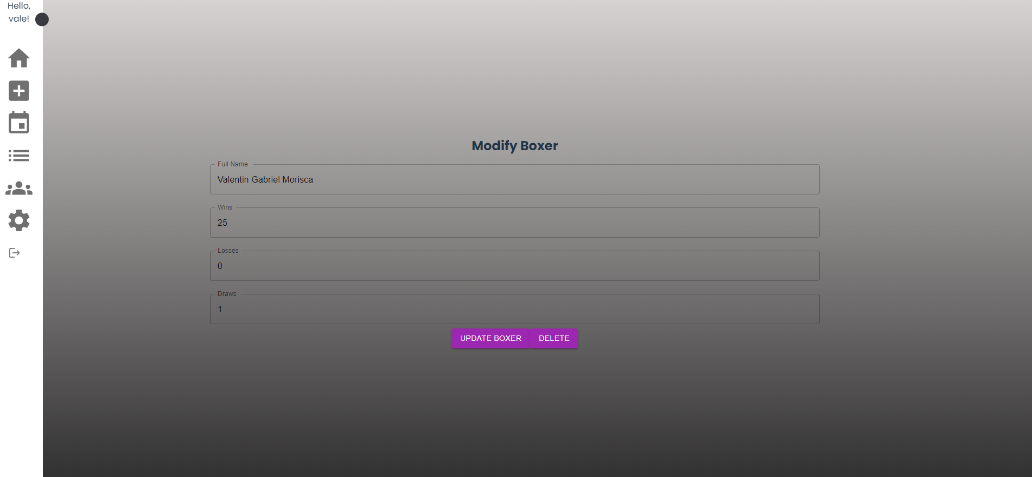

The Create Event Page had a few changes in the spacing between the input boxes, thus making it easier to read.

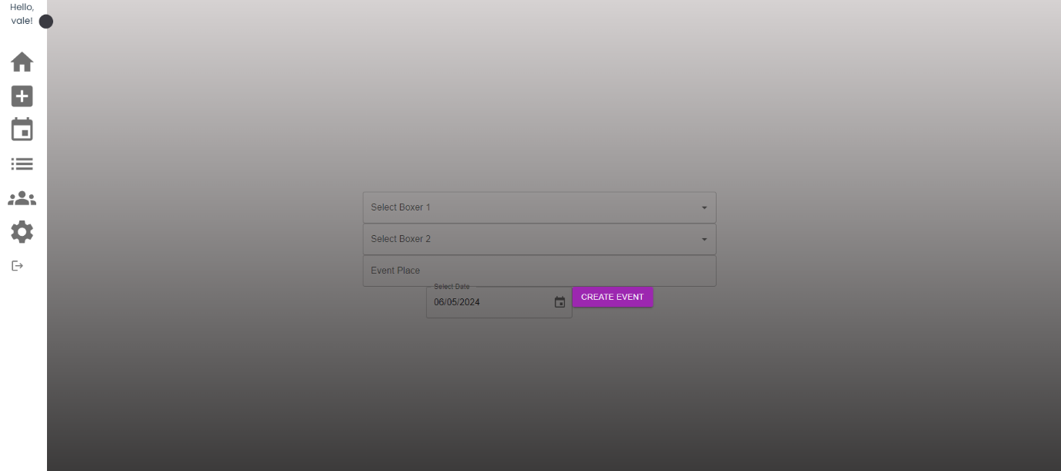

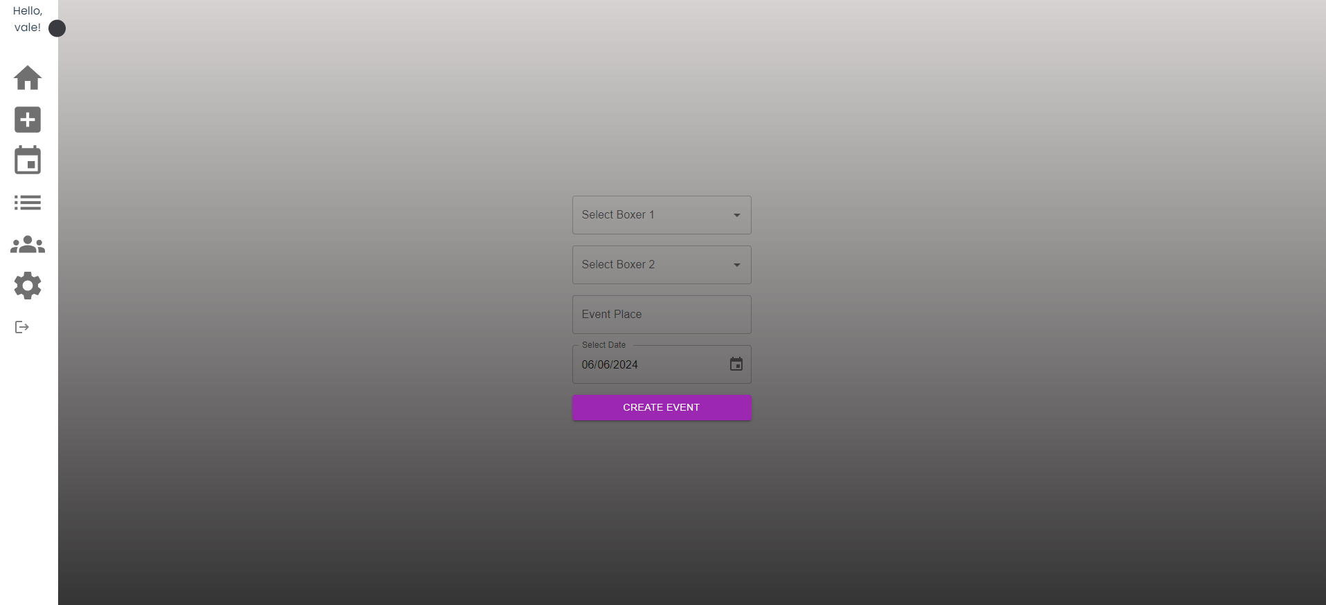

The List of Users Page did not undergo any changes.

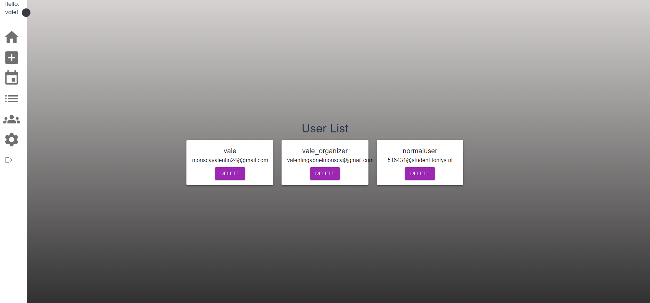

Page for User’s Settings:

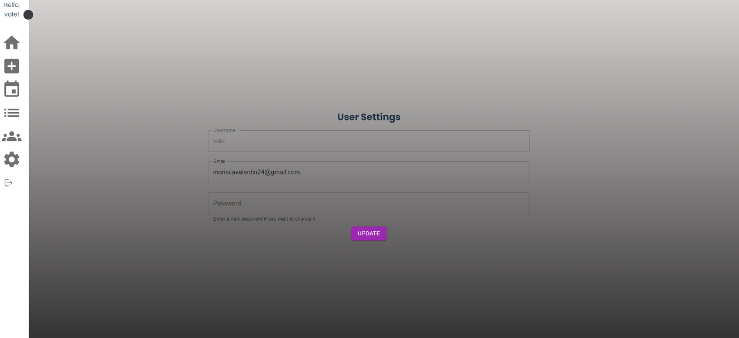

Also, validation checks have been added for some pages.

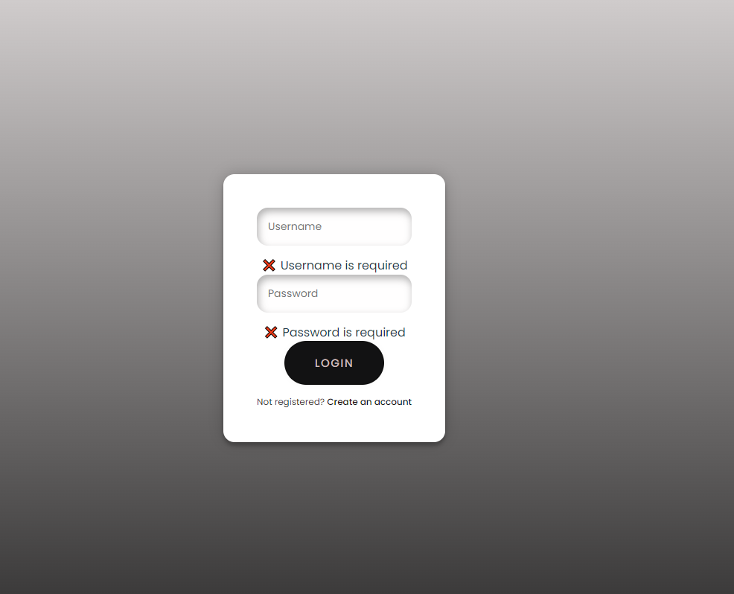

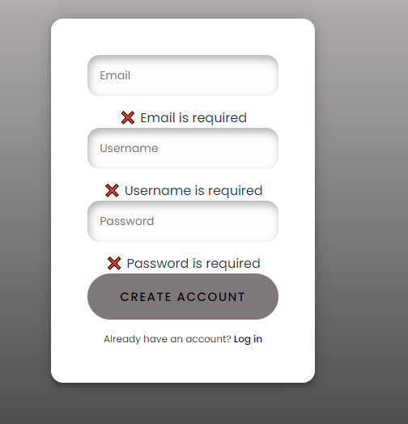

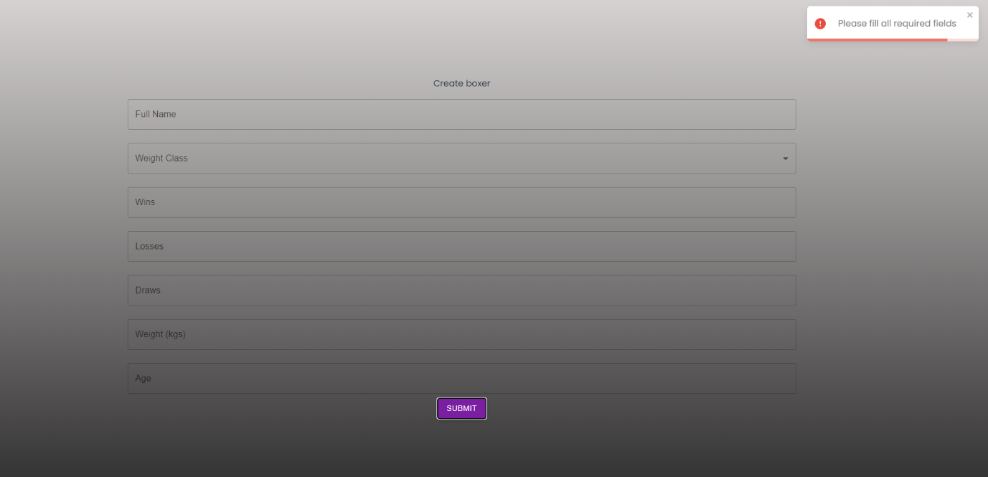

Also, a few Dialogs have been added to ensure that the user does not press a button by mistake, or ensure that they want those changes to happen.

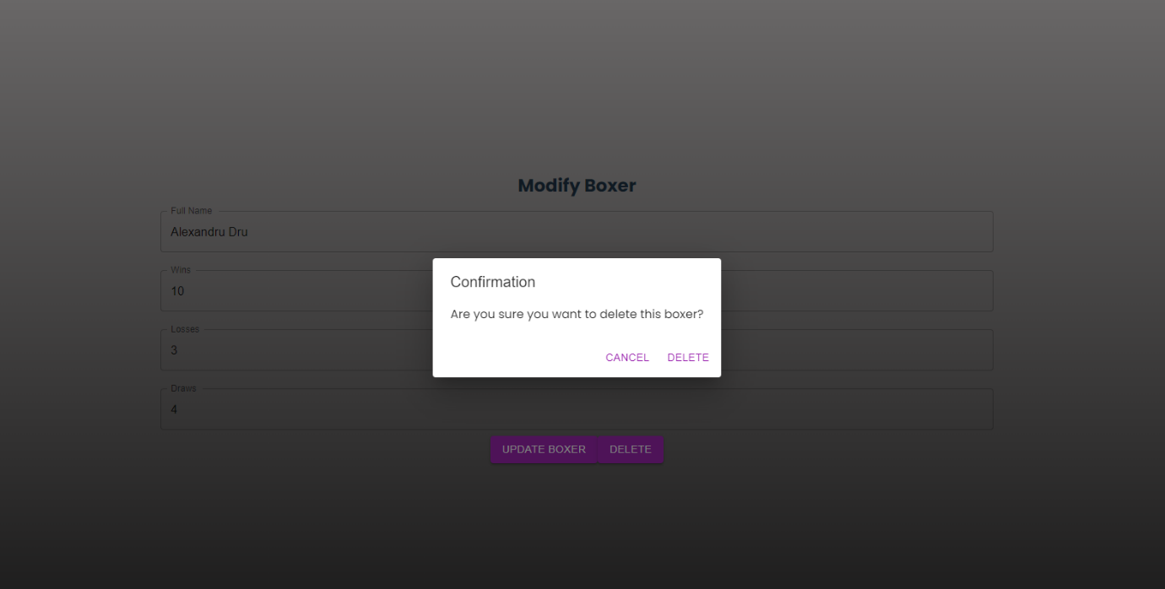

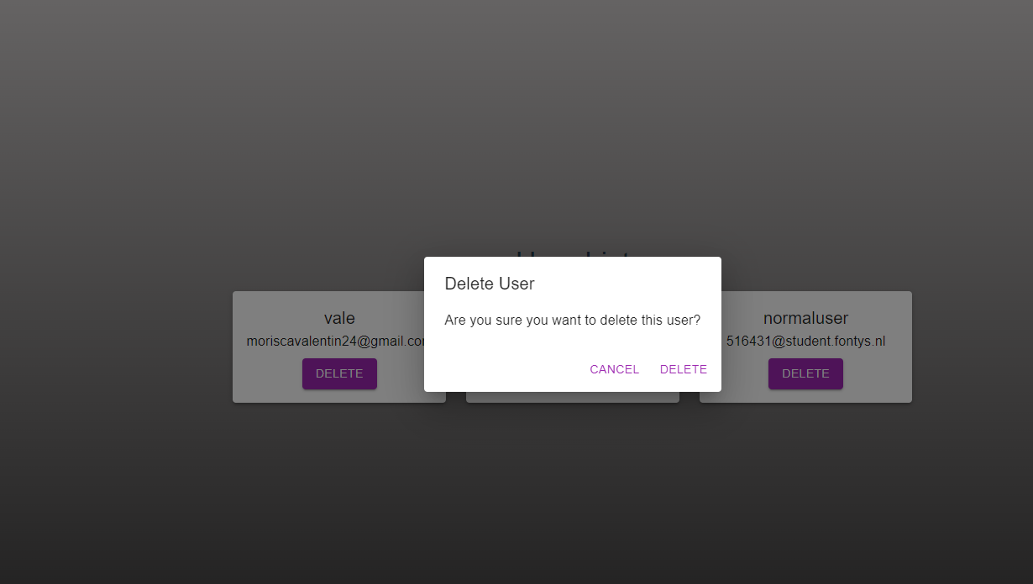

T Sidebar also shows the Role of the user.

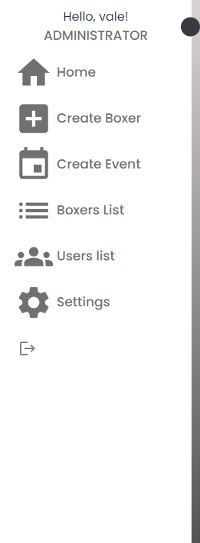

Other implemented pages since the update:  
